**FHIR Server Cors error For Swagger UI**

**#ERROR**

Following is an error related to the server cors.

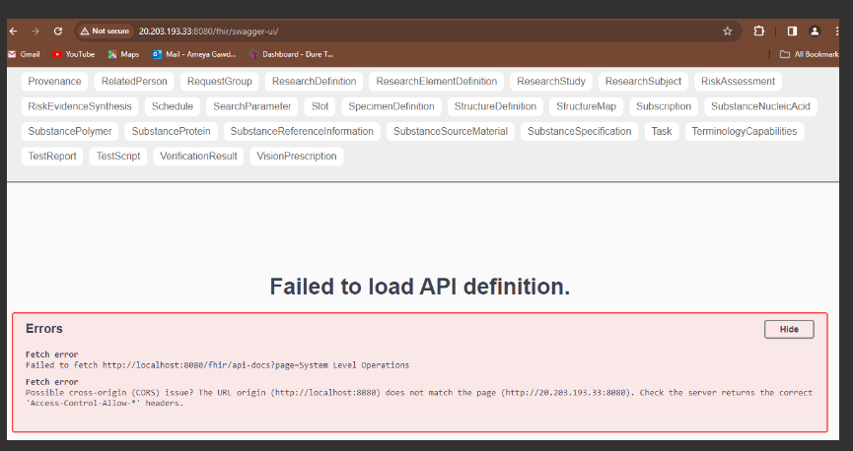

The system level operations not showing

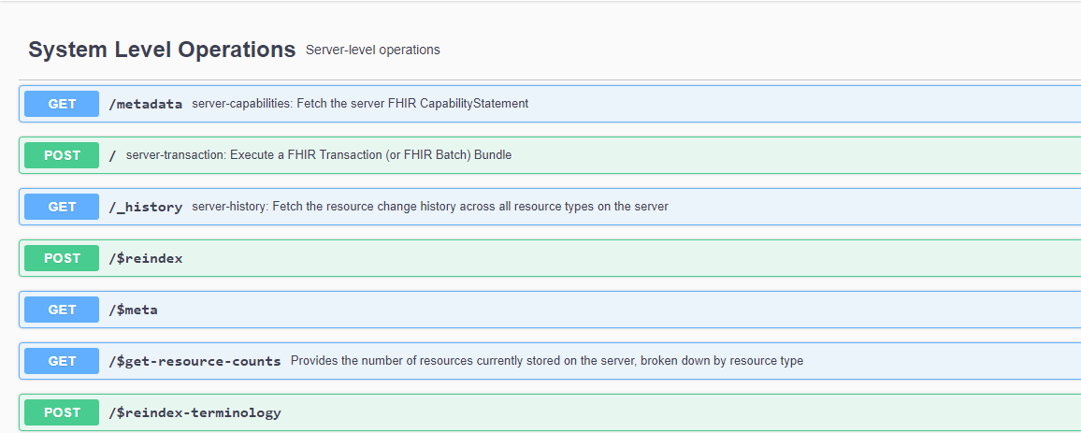

**#Solution**

1. Login to FHIR Server
2. Goto Tomcat directory
3. Cd /opt/tomcat/conf
4. Add Cros header in web.xml file.

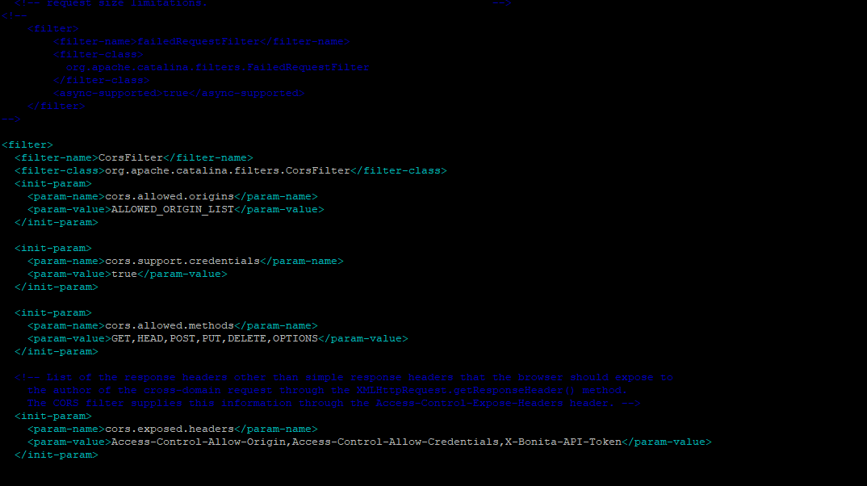

Tomcat configuration in web.xml file.

Add CORS filter following in the middle of the file.

**Important Note**: to use this configuration, you will need to replace the ALLOWED_ORIGIN_LIST by your own allowed origin list.

<filter>

<filter-name>CorsFilter</filter-name>

<filter-class>org.apache.catalina.filters.CorsFilter</filter-class>

<init-param>

<param-name>cors.allowed.origins</param-name>

<param-value>ALLOWED_ORIGIN_LIST</param-value>

</init-param>

<init-param>

<param-name>cors.support.credentials</param-name>

<param-value>true</param-value>

</init-param>

<init-param>

<param-name>cors.allowed.methods</param-name>

<param-value>GET,HEAD,POST,PUT,DELETE,OPTIONS</param-value>

</init-param>

<!-- List of the response headers other than simple response headers that the browser should expose to

the author of the cross-domain request through the XMLHttpRequest.getResponseHeader() method.

The CORS filter supplies this information through the Access-Control-Expose-Headers header. -->

<init-param>

<param-name>cors.exposed.headers</param-name>

<param-value>Access-Control-Allow-Origin,Access-Control-Allow-Credentials,X-Bonita-API-Token</param-value>

</init-param>

<!-- The names of the supported author request headers. These are advertised through the Access-Control-Allow-Headers header.

The CORS Filter implements this by simply echoing the requested value back to the browser.

-->

<init-param>

<param-name>cors.allowed.headers</param-name>

<param-value>Content-Type,X-Requested-With,accept,Origin,Access-Control-Request-Method,Access-Control-Request-Headers,X-Bonita-API-Token</param-value>

</init-param>

</filter>

...

<filter-mapping>

<filter-name>CorsFilter</filter-name>

<url-pattern>/*</url-pattern>

</filter-mapping>

Save the above content in the web.xml file

Check the FHIR SERVER URL

Resolved the Cros Server Issue.

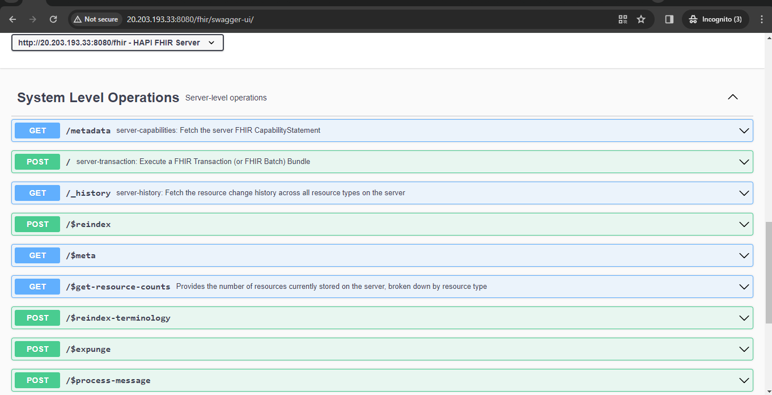

Reference URL:

https://documentation.bonitasoft.com/bonita/latest/security/enable-cors-in-tomcat-bundle#:~:text=Cross%2DOrigin%20Request%20Blocked%3A%20The,same%20domain%20or%20enabling%20CORS.